Sweden's indigenous Sami people win rights battle against state
Court grants Arctic village rights over hunting and fishing after lawyers for state were accused of ‘rhetoric of race biology’
Court grants Arctic village rights over hunting and fishing after lawyers for state were accused of ‘rhetoric of race biology’

Sami reindeer herders in northern Sweden. Photograph: Alamy
Sweden

Sweden's indigenous Sami people win rights battle against state
Court grants Arctic village rights over hunting and fishing after lawyers for state were accused of ‘rhetoric of race biology’
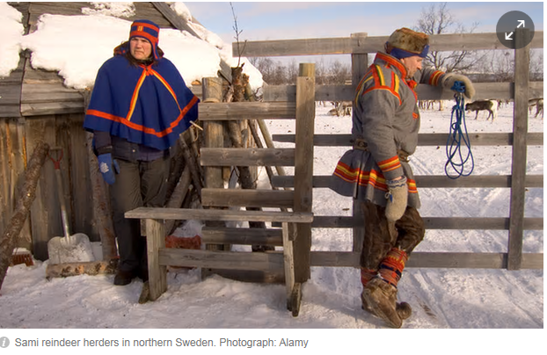

David Crouch in Gothenburg
Wednesday 3 February 2016 13.05 GMT Last modified on Wednesday 29 November 2017 03.08 GMT
Sweden’s nomadic reindeer herders have won a 30-year battle for land rights in a court case that has seen the state accused of racism towards the country’s only indigenous people.
A decision in Gällivare district court on Wednesday granted the tiny Sami village of Girjas, inside the Arctic Circle, exclusive rights to control hunting and fishing in the area, restoring powers stripped from the Sami people, or Laplanders, by Sweden’s parliament in 1993.
“It is a symbolic step towards getting Sami rights acknowledged, and we hope that this verdict can shape policies towards Sami issues in Sweden, that was the main goal,” said Åsa Larsson Blind, vice-president of the Sami Council, which represents Sami people in Sweden, Norway, Finland and Russia.
After a long struggle during which the Swedish Sami Association petitioned the European commission and the court of human rights, the case came to court in Sweden last year.
Lawyers for the state claimed that the indigenous status of the Samis was irrelevant to the case. “Sweden has in this matter no international obligations to recognise special rights of the Sami people, whether they are indigenous or not,” they said.
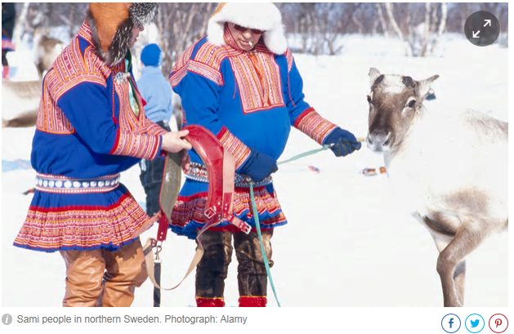

In an open letter, 59 academic researchers, including ethnographers and anthropologists at the Sami Research Centre at Umeå University, condemned the lawyers for using the “rhetoric of race biology” and revealing “a surprising ignorance of historical conditions”.
The Sami-Swedish artist and singer Sofia Jannok wrote: “The state wants to erase us from history.”
Larsson Blind said she was relieved that the court had seen through the “colonial speech” of state representatives. “By getting this verdict, many Sami individuals will feel strengthened after hearing the harsh wording used in the court,” she said.
Although the case concerned only a small geographical area, it came out of a far more general frustration that Sami issues were getting nowhere in the political arena, where they were debated endlessly but no decisions were taken, Larsson Blind said.
On the jagged northern tip of Norway, the Sami people still herd reindeer. But, inevitably, their life is changing …
Read more
The attorney general, Anna Skarhed, defended the state’s legal position last year and said there was “no question that the Sami are an indigenous people, but that is not the issue”. Lawyers may yet appeal, meaning the case could drag on for many more years, Larsson Blind said.
Welcoming the verdict, the chairman of Girjas village, Matti Berg, told Swedish media: “It is a long struggle and we have been victorious, I am so happy and relieved.” Berg faced threats of violence after the case was launched last year.
Some local Swedes are suspicious, however. “The next step will be restrictions on snowmobiling and moose hunting,” said Robert Björk, a hunter from Kiruna.
“The court’s decision is worrying for the hunters up here, but I assume that the verdict will be appealed [against],” Birgitta Isaksson from the Swedish Hunters Association in Kiruna told SVT.
Sweden does not register the ethnicity of its citizens, so exact numbers are not known, but about 20,000 Sami are estimated to live there, with a minority continuing the traditional reindeer-herding way of life. The Sami language was recognised as an official minority language in 2000.
Sweden’s Sami are also battling plans by Britain’s Beowulf Mining to mine iron ore in the country’s far north. “The verdict has no direct effect on mining plans, but it is one piece of the puzzle to get Sami land rights acknowledged so we can get more influence on mining,” Larsson Blind said.

